Chapter 3, Problem 60.

Calculate the power dissipated in each resistor in the circuit in Fig. 3.104.

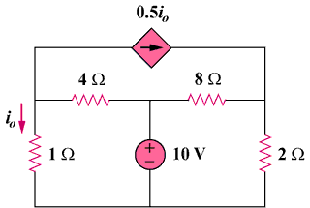

56 V

Figure 3.104
For Prob. 3.60.

